CS 121 Homework 1

John Ingram

8/23/19

**Problem one Simple calculations**

In one C/C++ Program translate the following three algebraic equations into C/C++ code. Then run the program with the given values stated below for x and y. Make sure that your results match the output as shown below. You may hard code the values for x and y or you can prompt the user to enter them.

Code:

//

// Program 1

//

#include <iostream>

#include <fstream>

#include <iomanip>

#include <string>

using namespace std;

float returnR();

float returnS();

float returnT();

int main(void)

{

printf("R = %f\n", returnR());

printf("S = %f\n", returnS());

printf("T = %f\n", returnT());

return 0;

}

float returnR()

{

float x = 3.37f;

return((3 * pow(x, 2)) + (5 * x) + 1);

}

float returnS()

{

float x = 9.385f;

return((pow(x, 2) - 12 * x + 27) / pow(x - 6, 2));

}

float returnT()

{

float x = 2.25f, y = 3.50f;

return(((pow(x, 2) + 3) / pow(y, 3)) + ((x + 2) / pow(y, 2)) + (1 / y));

}

**Output**

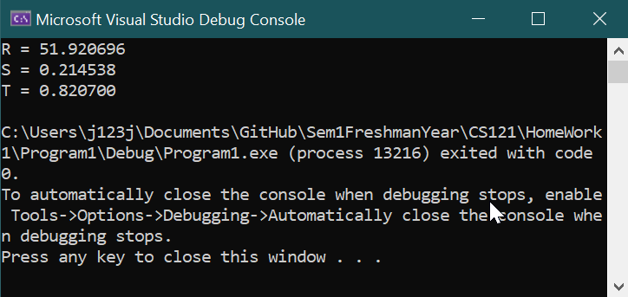

**Problem 2**

Program 2. The for loop  
  
Write a program that creates a table of temperatures in Celsius, Fahrenheit and Kelvin. The program will prompt the user to enter the starting temperature, the ending temperature and the increment between values all in Celsius. The program will then use a **for loop** to convert Celsius to Fahrenheit AND Kelvin creating a table of temperatures similar to that shown below where the start temperature was 0 degrees C, ending temp was 100 degrees C and the increment was 10 degrees C. (Your temperature choices may be different)

Code:

//

// Program 2

//

#include <iostream>

#include <fstream>

#include <iomanip>

#include <string>

using namespace std;

float cToF(float celsius);

float cToK(float celsius);

int main(void)

{

float start = 0, increment = 0, finalTemp = 0;

printf("Enter a starting temperature in degrees Celsius: ");

scanf_s("%f", &start);

printf("Enter an ending temperature in degrees Celsius: ");

scanf_s("%f", &finalTemp);

printf("Enter the increment between temperatures in degrees Celsius: ");

scanf_s("%f", &increment);

printf("Celsius Farenheit Kelvin\n");

//8 11 8

for (float current = start; current <= finalTemp; current += increment)

{

printf("%-10.2f", current);

printf("%-10.2f", cToF(current));

printf("%-8.2f", cToK(current));

printf("\n");

}

return 0;

}

float cToF(float celsius)

{

return 9.0f / 5.0f * celsius + 32.0f;

}

float cToK(float celsius)

{

return celsius + 273.15f;

}

**Output:**

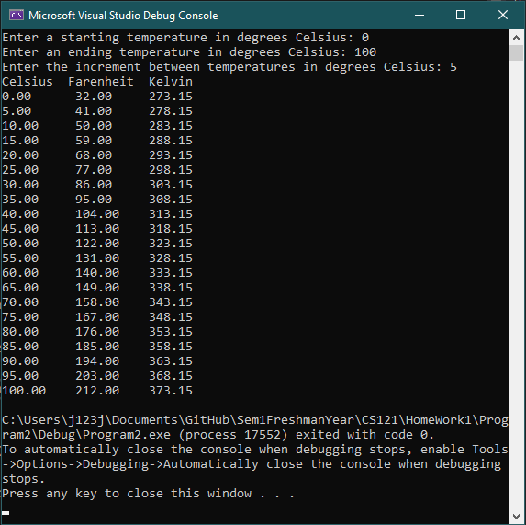

Program 3. The while or do while loop

Using the **while loop** or the **do – while loop** write a program that does the following:

Calculate the average of a series of homework grades (0 - 100) entered **one at a time**. In this case the lowest score will be dropped and the average computed with the remaining grades.

For example suppose you enter the following grades: 78, 85, 81, 90, 88, 93 and 97.

The average will be computed from the 6 grades 85, 81, 90, 88, 93 and 97. The low score of 78 will be dropped.

Output each grade, the dropped grade and the final average.

Code

//

// Program 3

//

#include <iostream>

#include <fstream>

#include <iomanip>

#include <vector>

#include <string>

using namespace std;

int main(void)

{

float min = 9999;

vector<float> grades;

int count = 0;

string input;

while (true)

{

cout << "Enter a grade or enter 'C' to compute the average " << endl;

cin >> input;

if (input == "C")

{

break;

}

else if (strtof((input).c_str(), 0) < min)

{

if (min != 9999)

{

grades.push_back(min);

count++;

}

min = strtof((input).c_str(), 0);

}

else

{

grades.push_back(strtof((input).c_str(), 0));

count++;

}

}

cout << "The average of the " << grades.size() << " grades ";

//Output grades

for (auto const& grade : grades)

{

cout << grade << ' ';

}

cout << endl << "The lowest grade " << min << " will be dropped" << endl;

int i = 0;

float total = 0;

while (i < grades.size())

{

total += grades[i];

i++;

}

cout << "Average: " << (total / i) << endl;

return 0;

}

Output

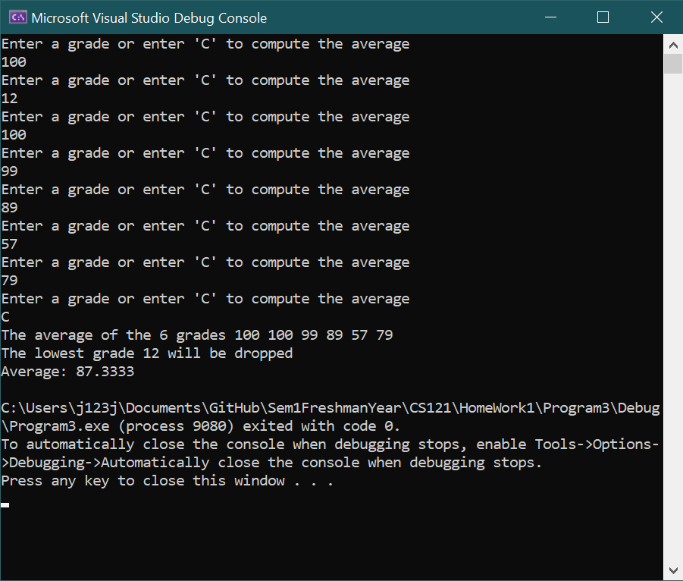

**Program 4. Functions**

The Body Mass Index is computer by the following formula:

BMI = (weight in pounds) / (height in inches squared) * 703

Write a program with one function that computes the BMI value from a person’s weight and height. The main program will prompt the user to enter weight in pounds. Then it will prompt the user to enter height in feet and inches. These three values will then be passed to a function that will compute and return the resulting body mass index as a real number. The function will have to convert feet and inches to total height in inches before calculating BMI.

**Code**

//

// Program 4

//

#include <iostream>

#include <fstream>

#include <iomanip>

#include <string>

using namespace std;

//BMI = (weight in pounds) / (height in inches squared) * 703

float getBMI(float weight, float height);

int main(void)

{

float weight, height;

cout << fixed << setprecision(2);

cout << "This program will calculate your BMI" << endl;

cout << "Enter your weight in pounds: ";

cin >> weight;

cout << "Enter your height in inches: ";

cin >> height;

cout << "Your BMI is " << getBMI(weight, height) << endl;

system("pause");

return 0;

}

float getBMI(float weight, float height)

{

return weight / pow(height, 2) * 703;

}

**Output**

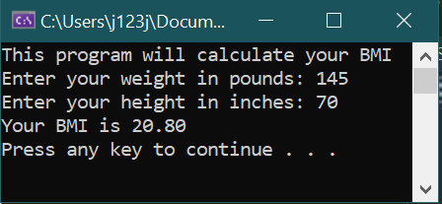

**Program 5. One dimensional arrays**

Write a program that performs the following operations on a one dimensional array with 50 unsigned integers. The main program will initialize the array, print the array values to the screen and then call a function that will determine and print the maximum and minimum values.

Declare the array and any other variables.

Use a loop to initialize the array with 50 random integer values between 0 and 99 using the rand() function. (number = rand() % 100;)

Print the initialized array to the screen. All 50 numbers. Can you set it up so that it prints five lines with 10 numbers each?

The main program then calls a function that determines the maximum and minimum values in the array and prints them to the screen.

//

// Program5

//

#include <iostream>

#include <fstream>

#include <iomanip>

#include <string>

using namespace std;

int main(void)

{

int numbers[50];

for (int i = 0; i < 50; i++)

{

numbers[i] = rand() % 100;

}

for (int i = 0; i < 5; i++)

{

for (int k = i * 10; k < (i + 1) * 10; k++)

{

cout << setw(2) << numbers[k] << ' ';

}

cout << endl;

}

system("pause");

return 0;

}

**Output**

